<Google classroom>

**Online Learning Platform**

Use-Case Specification: <User Settings>

Version <1.1>

Revision History

| **Date** | **Version** | **Description** | **Author** |
| --- | --- | --- | --- |
| 05/12/2021 | <1.0> | Initial version | Le Hong Hai |
| 09/12/2021 | <1.1> | Edited version | Le Hong Hai |
|  |  |  |  |
|  |  |  |  |

Table of Contents

1. Use-Case Name 3

1.1 Brief Description 3

2. Flow of Events 3

2.1 Basic Flow 3

2.2 Alternative Flows 3

2.2.1 < First Alternative Flow > 3

2.2.2 < Second Alternative Flow > 3

3. Special Requirements 3

3.1 < First Special Requirement > 3

4. Preconditions 3

4.1 < Precondition One > 3

5. Postconditions 3

5.1 < Postcondition One > 3

6. Extension Points 3

6.1 <Name of Extension Point> 3

Use-Case Specification: <User Settings>

# Use-Case Name

## Brief Description

- This process for user to set Account in Google Classroom

- For who: users

- The purpose: helping users to set things related to the user's account (change profile image, change name, turn on/ turn off notifications about comments, classes).

# Flow of Events

## Basic Flow

First, at the top left, move mouse pointer to Menu icon (icon ) (when hovering over this icon, the mouse pointer will turn into a pointing hand icon, it will appear as a tooltip like a small box named “Main Menu '' with text color: white and background-color: black. Also, the menu icon background will be blurred a little bit with a gray circle around it).

Then, when clicking 1 time in this Menu icon (), Menu icon disappeared and a selection panel (background-color: white) will be displayed in left-side (including “Classes” with icon like a house in the left-side of “Classes” text, “Calendar”- under “Classes” with icon calendar in the left-side of “Calendar” text, “Enrolled” with “To-do” with notebook icon in the left-side of “To-do” text, user’s classes with different color cycle icon in the left-side of class’s name , “Archived classes” with save icon in the left-side of it and “Settings” with bolts icon in left-side of it respectively). Text-color in this selection panel is black.

When hovering the mouse pointer in the “Settings” part (with icon bolts in the left and text “Settings” beside), the mouse pointer will turn into a pointing hand icon with text color: black and background will be blurred with gray color a little bit).

Then, click it 1 time. A new page will appear (with background-color: white; text: black).

In the top right, they are icon () and icon profile of the user respectively from left to right. In the top left, they are Menu icon () in the left-side and text “Settings” in right-side.

Under, it is text “Profile” with the image of user (user can change it when click “Change” beside), then a new page will be displayed, user can change the image by click button “Select a photo from your computer” (background-color: gray; text-color: black, in the middle of the box, border-color: blue) 🡪 Choose any image in user’s computer 🡪 Click to button “Set as profile photo” to set profile image (background-color: blue; text-color: white; at the bottom left of the box). Other Hand, user can pick uploaded photo when clicking in “Your photos” part next to “Upload photos” to choose an available image (there are a list of images will be displayed with its time uploaded (background-color: white, text-color: black and number of photos in this collection with text-color: gray), then user choose image what they want by clicking into it, a new page will be displayed (with background-color: white, text-color: black; named “Select profile photo”, and directory of this image and notification “To crop this image, drag the region below and then click “Set as profile photo” respectively from above to under) for user to crop and edit before confirm to set image profile. Moreover, user can rotate the image by click 1 time in ( ) or () which is beside the image on the right-side. Also, user can add caption to the image by clicking “Add caption” (text-color: blue, below the editing image), notification “Press Enter to apply or Esc to cancel” and above is a input rectangular form with border-color: black, then user input to input rectangular form to add more some caption, then click “Enter” from keyboard to confirm, otherwise click “Esc” from keyboard to cancel 🡪 Click to button “Set a profile photo” (background-color: blue; text-color: white, left bottom) to set profile image. However, users can dismiss the setting profile process by clicking the “Cancel” (beside “Set as profile photo in the left-side, background-color: gray, text-color: black). Then back to the page of Account Settings.

Users can change the name by clicking “account settings”. Then a new page in a new tab in the browser will appear. Users change name by editing in “CHANGE NAME” form with “First name” and “Last name” (background-color: white; text-color: black, the center of current page). Afterward, the user clicks the button “Save” with background-color: blue and text-color: white to save information and a notification will be displayed “Your change might take a while to show everyone”. It’s done!

Under, in “Notifications” part, user can turn on/ turn off notifications by clicking to icon

( ), there are notifications (background-color: white; text-color: black) related to “Comments” with text-size is bigger than normal including “Comments on your posts”, “Comments that mention you”, “Private comments on work” from above to under; Next, “Classes you’re enrolled in” with text-size is bigger than normal including “Work and other posts from teachers”, “Return work and grades from your teacher”, “Invitations to join classes as a student” and “Due-date reminders for your work” from above to under; Next, “Classes you teach” with text-size bigger than normal including “Late submissions of student work”, “Resubmissions of student work”, “Invitations to co-teach classes”, “Scheduled post published or failed” from above to under.Finally, it is “Class notification”

with text “Turn email and mobile notifications on or off for a class”, click icon () in the right-side to expand more information about classes. That’s it!



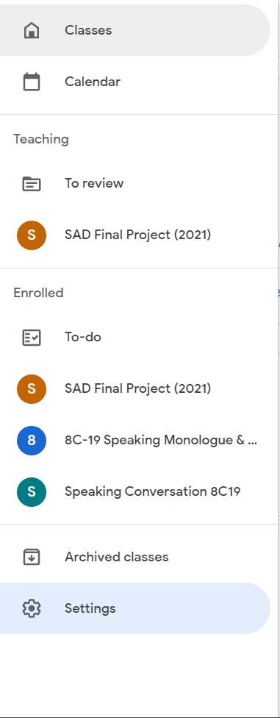

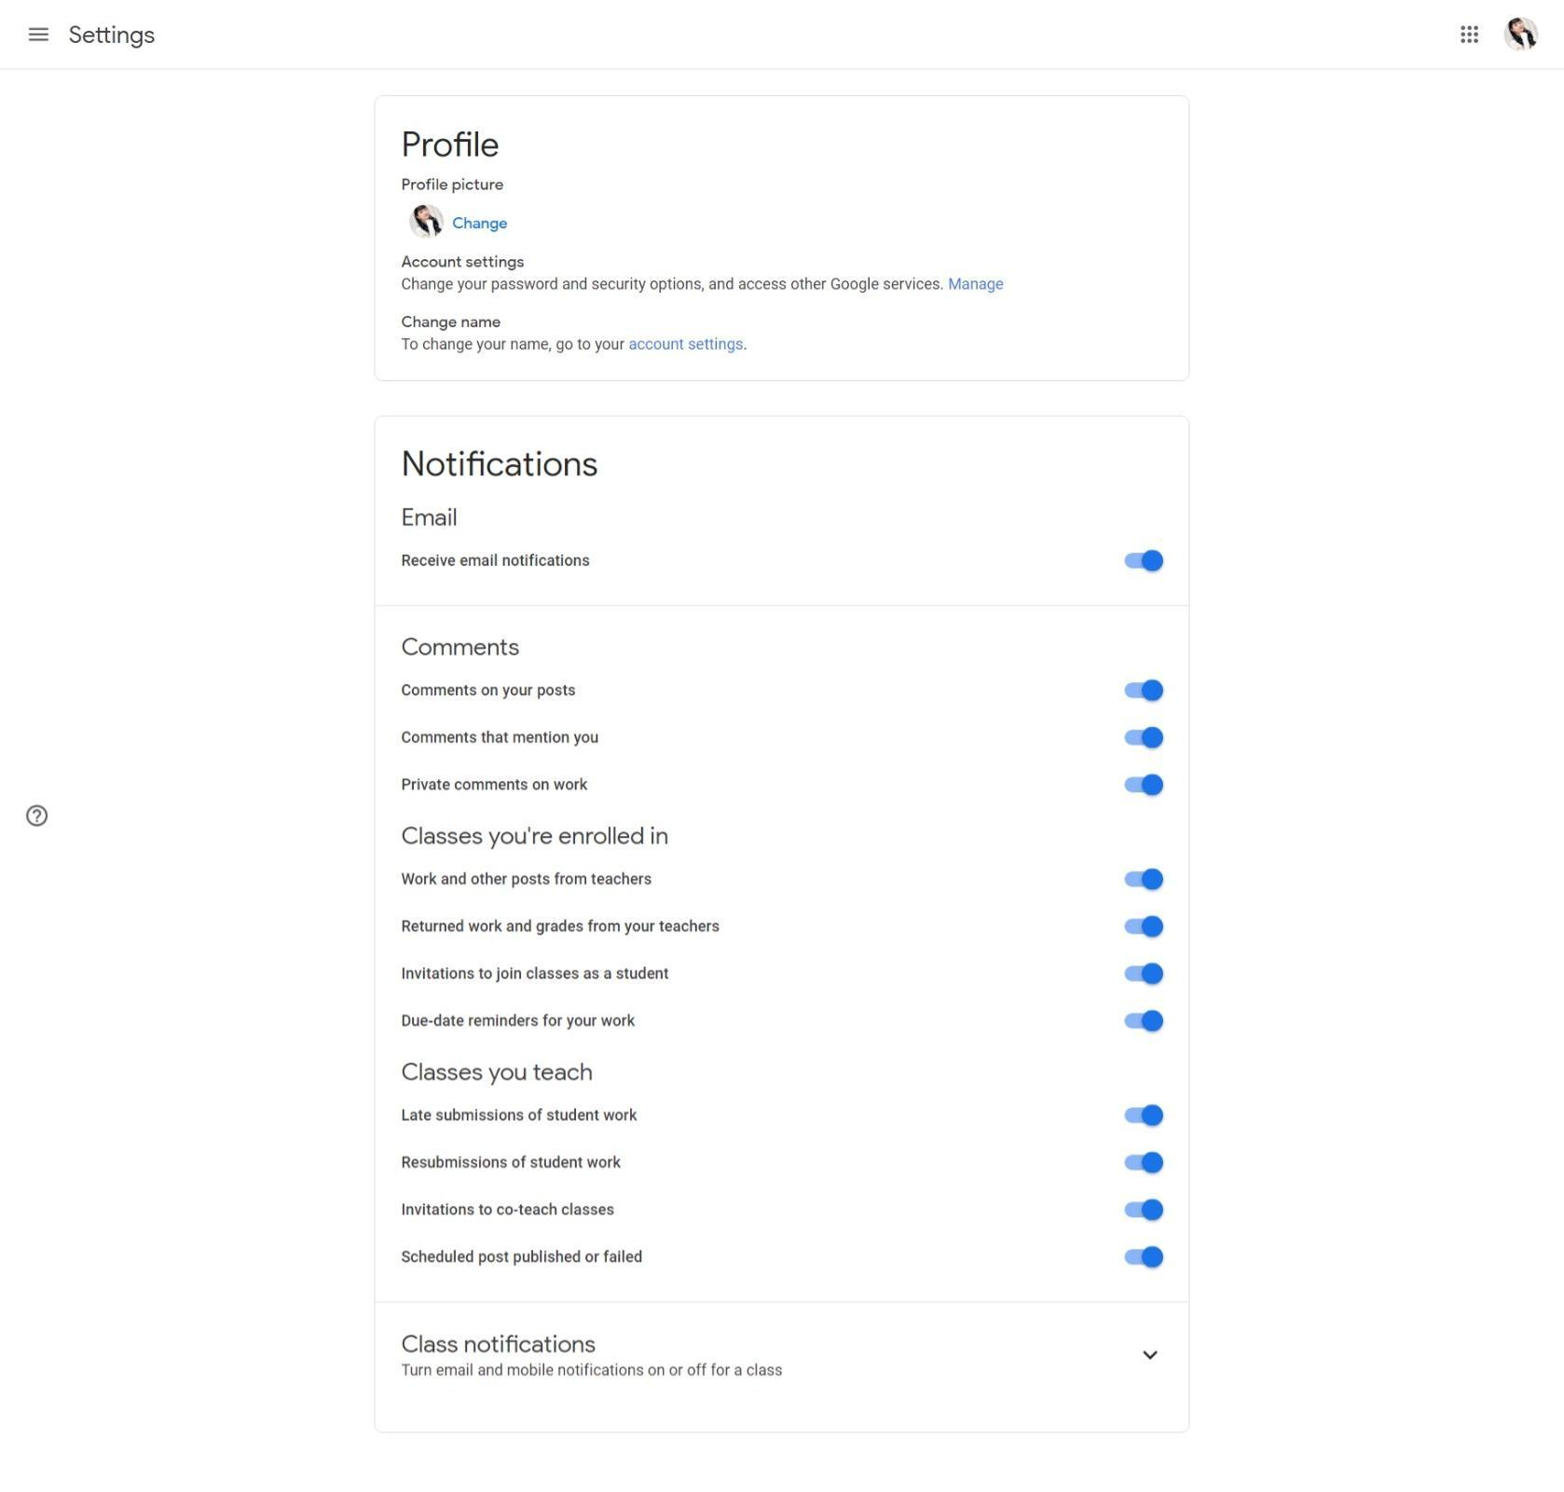

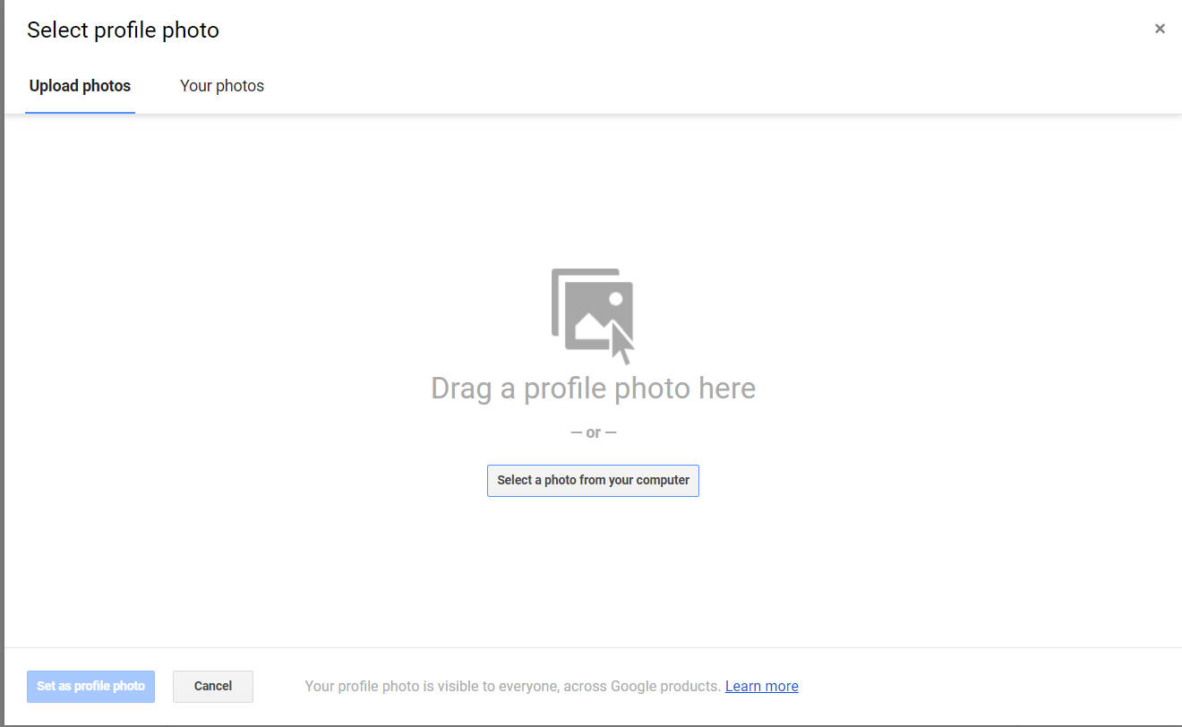

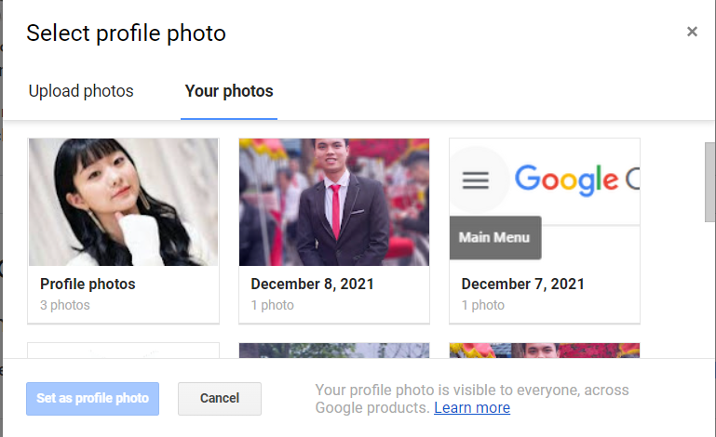

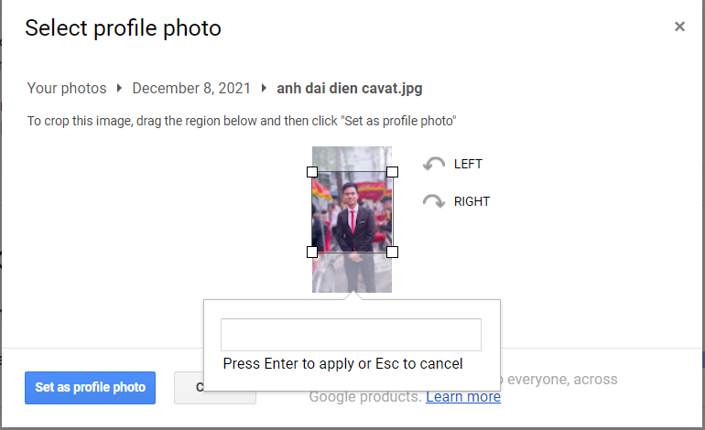

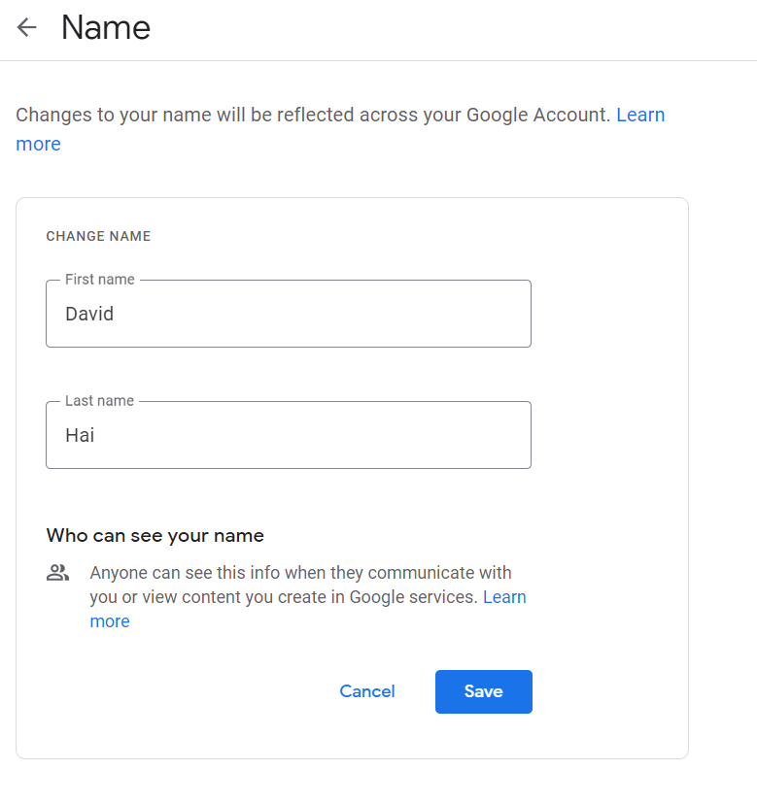

## Alternative Flows

None

# Special Requirements

## None

# Preconditions

## Users must login successfully first!

# Postconditions

## None

# Extension Points

## None